Adding keyboard file

- Click Add New button.

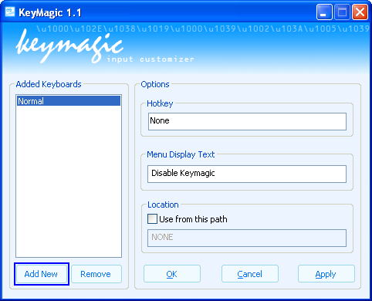

- Select the keyboard file and click open.

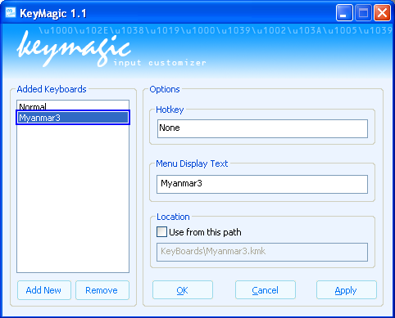

- If you see keyboard name in the list, it's ready to use. (You will need to restart the application which you want to use together with Keymagic).

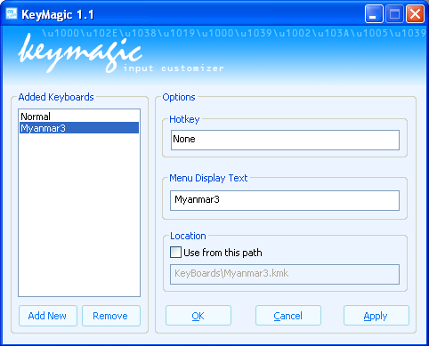

Adding keyboard file from explorer

- Explore the path where keyboard file located.

- Right click on the keyboard file.

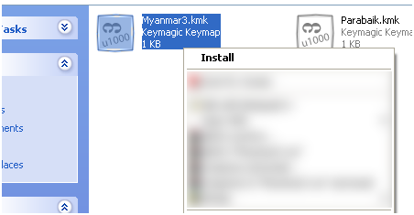

- Select Install.

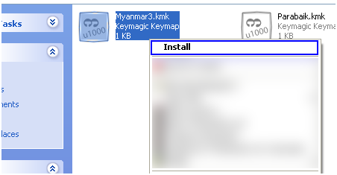

(Note: Myanmar Keyboard files are located in {INSTALLDIR}\Keyboards; you will need to add keyboard file yourself by one of the above method)

Removing keyboard file

- Select the keyboard name that you want to remove.

- Click Remove button.

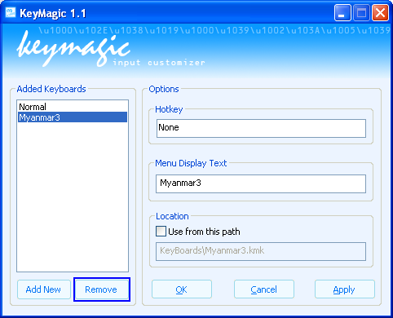

- Click Apply button.
- Keyboard has been removed.

Setting hotkey

- Select a keyboard name that you want to set hotkey.

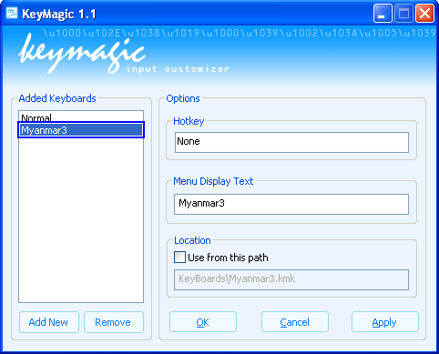

- Click on the Hotkey box and press keys that you want to set as hotkey.

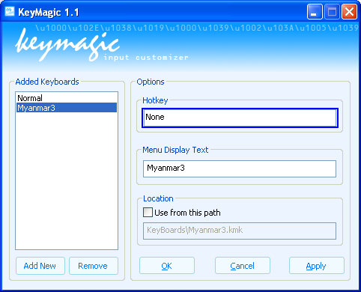

- Click Apply button.

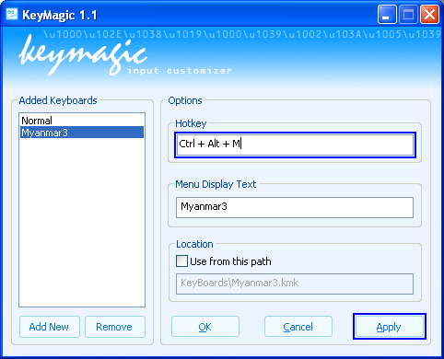

Setting keyboard path
(Use only when you want to use Keymagic from Removable Drive)

- Check Use from this path.

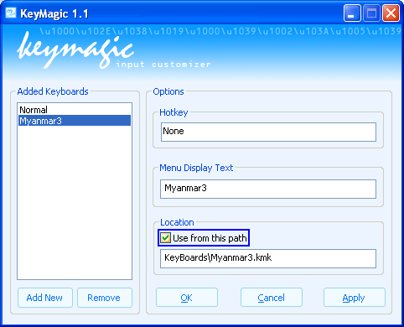

- Provide a full path to a keyboard file.

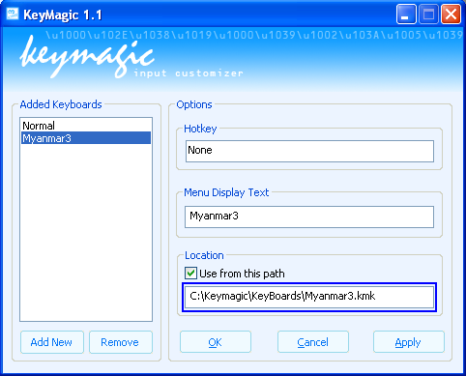

- Click Apply button.

Selecting keyboard from the Tray Icon
- Left Click on the Keymagic tray.

- Select a keyboard file, you want to use.

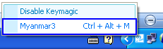

Activating keyboard with Hotkey
- Just press a hotkey you have set.

Closing Keymagic
- Right Click on the Keymagic tray.

- Click Exit.

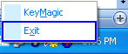

Syntax Used in Keymap scripting

\\
Use to represent \.

\(Decimal Value)
Use to represent Hex Value.
(e.g. \65 = 0x41 = A)
\065, \0100 (Don’t put zero)

//(Comment String)
Use to represent Comment.

